**WEE BOX**

Instructions and Spec Sheet

Rev. October 2023

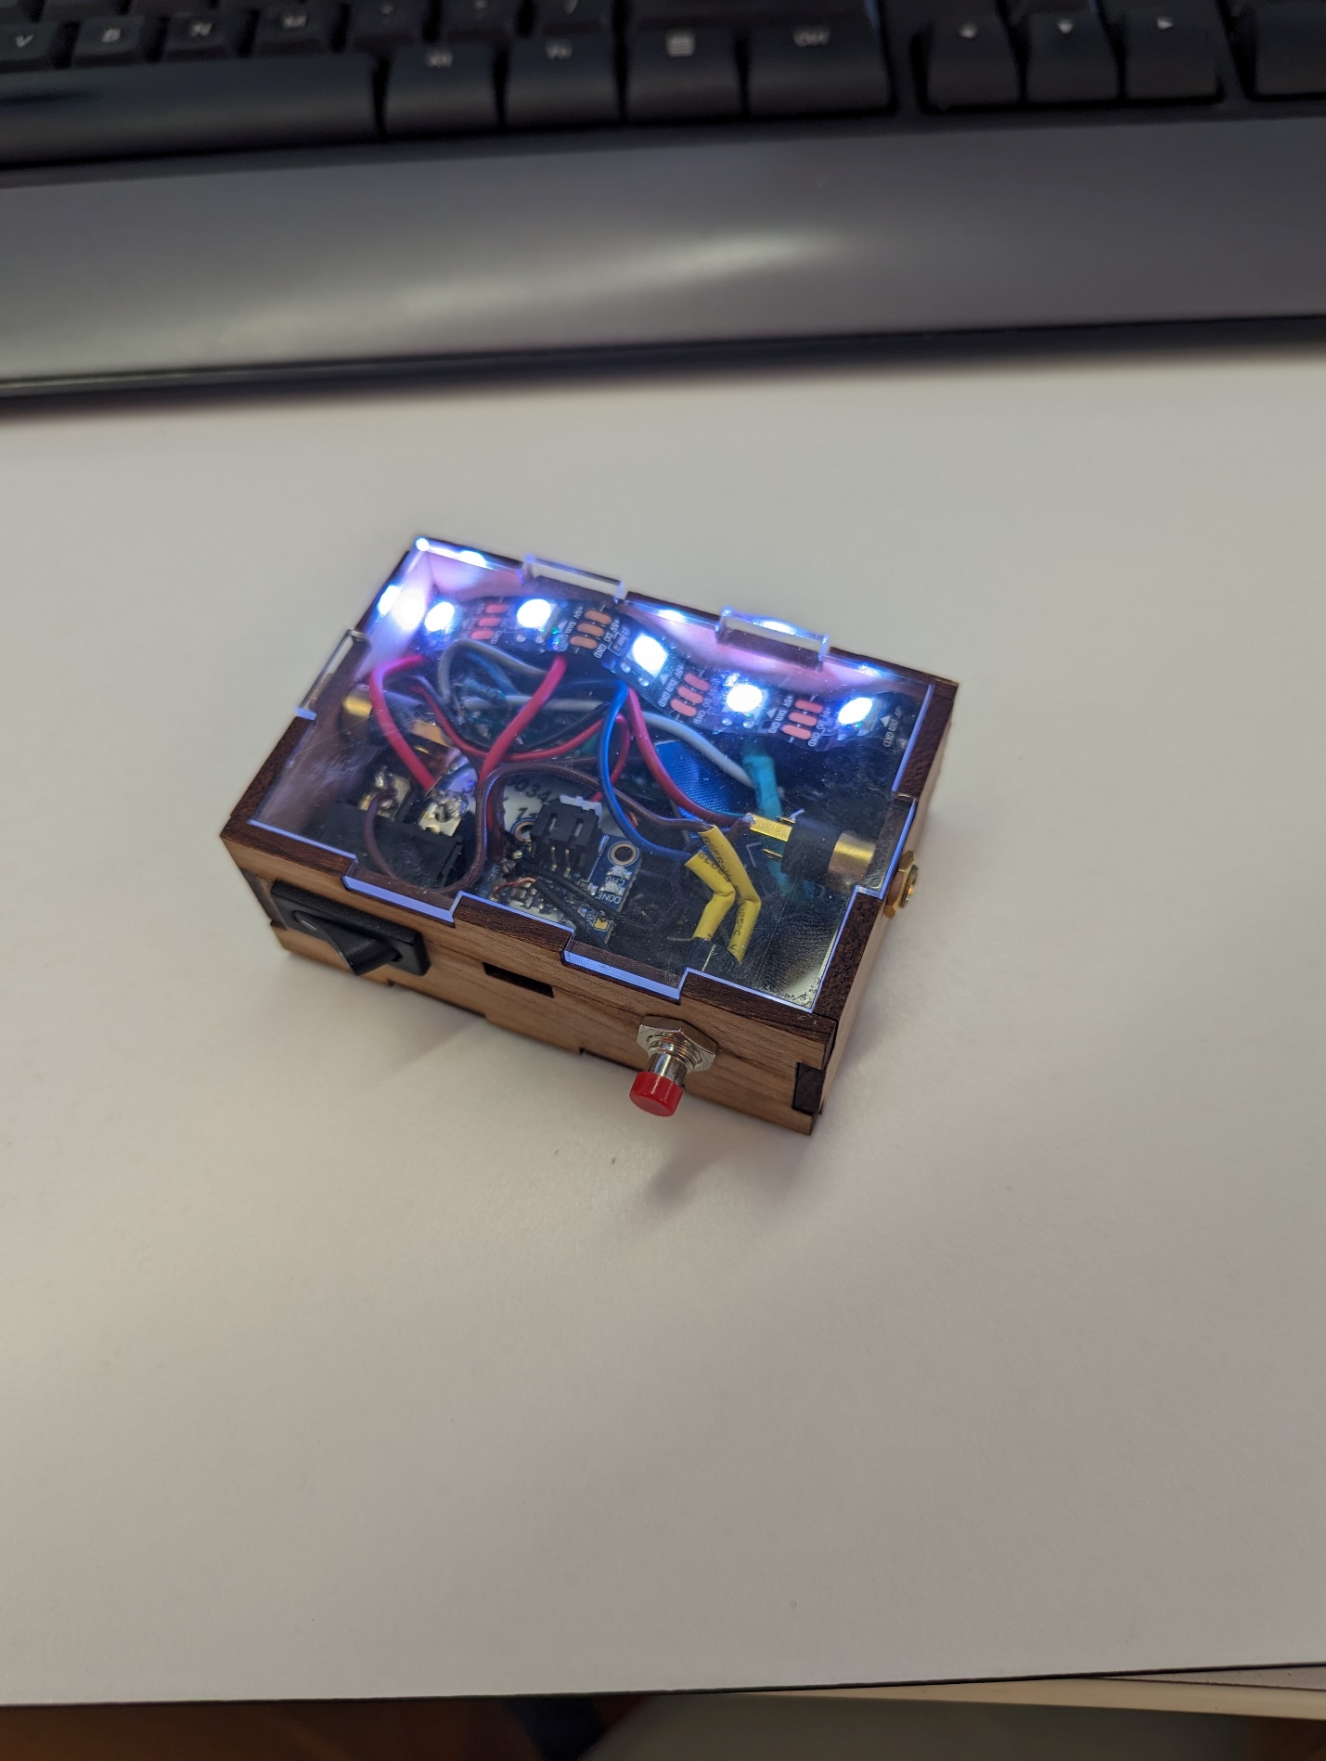

**Overview:**

The “Wee Box” is a standalone arduino based system for activation of accessible switches using common components in a package that can be assembled by an untrained person. It utilizes laser cut plywood and acrylic (available at most library maker spaces) for encasing the components. Everything shown can be purchased via amazon.com though electronics distributors such as digikey.com and mouser.com may be used as well for individual component purchase if desired.

**Function:**

The box takes a simple input from the piezo switch which measures changes in force, and tests if a threshold of activation has been exceeded. If this threshold is exceeded the arduino activates the output which will simulate a button press of an accessible device.

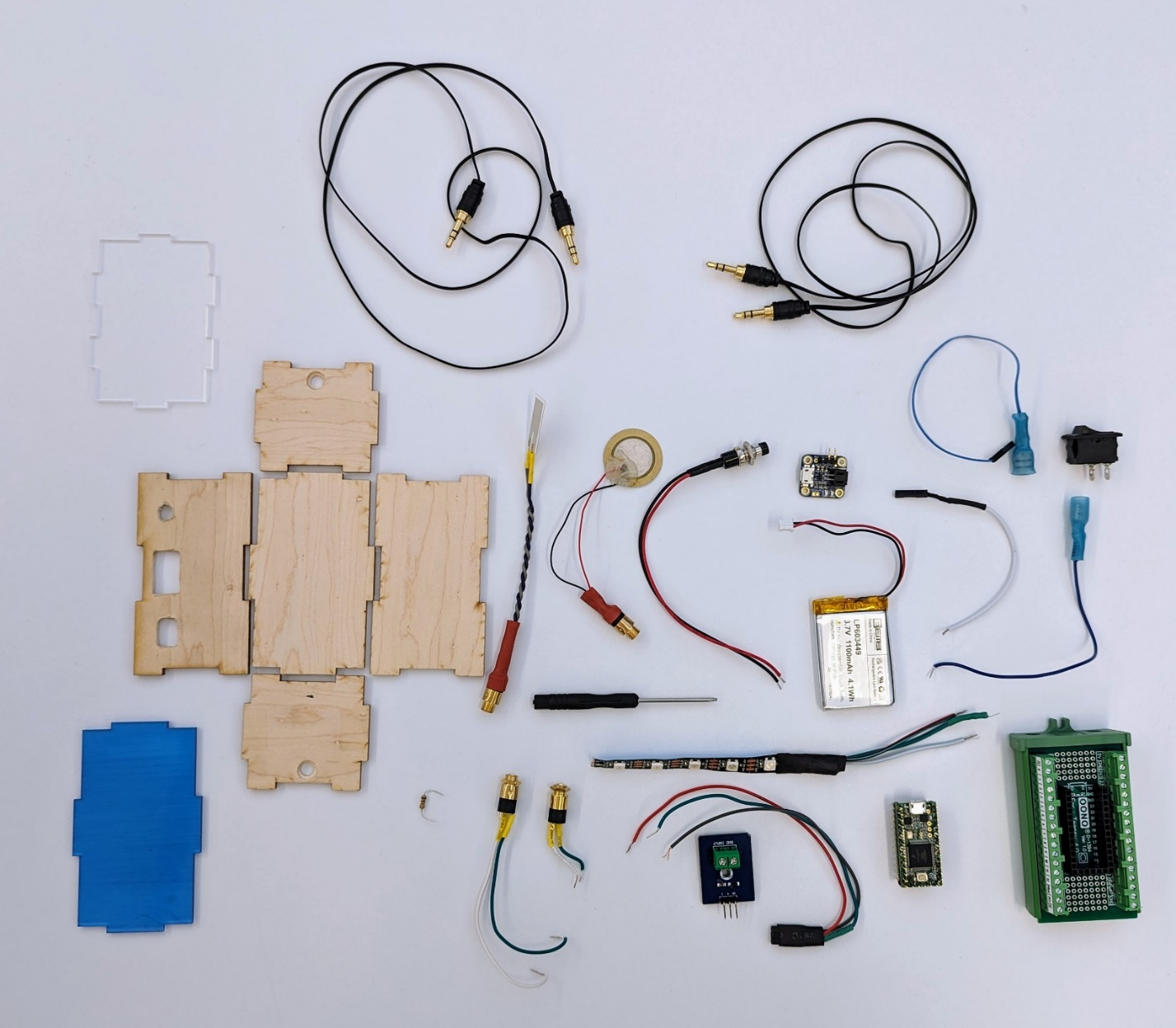

1.

14.

11.

15.

16.

13.

12.

9.

8.

6.

5.

4.

7.

3.

2.

10.

**All necessary components for construction of the “Wee Box”**

1. 3.5mm connection wires
2. Piezo Switch
3. Pushbutton
4. Battery Charger
5. Power connector
6. On-Off switch
7. LiPo Battery
8. Power Connector to Arduino
9. Power connector
10. 10kΩ and 300Ω Resistor
11. 3.5mm Jacks
12. LED strip (with 100μF capacitor across + and – leads)
13. Teensy breakout board
14. Piezo switch module
15. LED Connector
16. Teensy 4.0 Microcontroller

**Construction:**

1. You should first load the arduino software onto the teensy microcontroller **(16.)**
   1. This code is called “wee_box.ino”
   2. It requires that you install the Arduino software on a computer, this is a free software
   3. Follow online instructions for loading software onto a teensy microcontroller via micro-usb cable
2. Attach female terminal spade to power cables **(finished shown in 5. And 9.)**
3. Attach spaded wire **(5.)** to outside terminal of switch **(6.)**
   1. Attach other end to “3V” terminal of the breakout box **(13.)** tighten with screwdriver
4. Attach spaded wire **(9.)** to middle terminal of switch **(6.)**
   1. Attach other end to “Bat” pin of USB charger **(4.)**
5. Attach female terminal spades to 3.5mm jack wires
   1. Attach to pins of 3.5mm jacks  
       View when looking at 3.5mm jack pins

1

2

3

* + 1. Green goes to pin 1 on both jacks
    2. White goes to pin 2 on one of the jacks (output) and pin 3 on the other (input)
  1. Completed shown in **11.**

1. Attach input jack green wire, pin 1, to “GND” terminal on Pizeo module **(14.)** tighten with screwdriver
2. Attach input jack white wire, pin 3, to “Input” terminal on Piezo module **(14.)** tighten with screwdriver
3. Attach output jack green wire, pin 1, to “GND” terminal of breakout box **(13.)** tighten with screwdriver
4. Attach output jack white wire, pin 3, to “13” terminal pin of breakout box **(13.)** tighten with screwdriver
5. Attach 3 wires **(15.)** from Piezo module **(14.)** to breakout box **(13.)**
   1. “S” pin of Piezo module **(14.)** to pin “14” of breakout box **(13.)**
   2. “+” pin of Piezo module **(14.)** to pin “3V3” of breakout box **(13.)**
   3. “S” pin of Piezo module **(14.)** to pin “GND” of breakout box **(13.)**
6. Attach wires from pushbutton **(3.)** to breakout box **(13.)**
   1. Attach red wire from pushbutton **(3.)** to pin “2” of breakout box **(13.)** DO NOT TIGHTEN YET
   2. Attach black wire from pushbutton **(3.)** to pin “GND” of breakout box **(13.)** DO NOT TIGHTEN YET
   3. Place 10kΩ resistor **(10.)** across pins “2” and “GND” of breakout box **(13.)** NOW TIGHTEN PIN “2” AND “GND” WITH WIRES AND RESISTOR PLACED
7. Attach wires from LED strip **(12.)** to breakout box **(13.)**
   1. Attach white wire from LED strip **(12.)** to “GND” pin on breakout box **(13.)** DO NOT TIGHTEN YET
   2. Attach black wire from LED strip **(12.)** to “3V3” pin on breakout box **(13.)** DO NOT TIGHTEN YET
   3. Attach 100μF capacitor across terminals “GND” and “3V3”
      1. **IF USING POLARIZED CAPACITOR MAKE SURE THE “-“ SIDE OF CAPACITOR IS ATTACHED TO “GND” AND “+” SIDE IS ATTACHED TO “3V3”**
   4. Tighten “GND” and “3V3” Pins on breakout box **(13.)**
   5. The 300Ω resistor should be placed in line with the green wire of the LED strip **(12.)**
      1. This can be done in a variety of ways, using terminal spades or twisting with electrical tape
      2. Attach Green wire from LED strip **(12.)** to pin “6” on breakout box **(13.) Electric-Tape 300Ω**

LED Pin “6”

1. Attaching Battery **(7.)** to usb charger **(4.)** 
   1. **VERY IMPORTANT SOME BATTERIES HAVE BACKWARDS CABLES BEFORE PLUGGING IN BATTERY (7.) TO CHARGER (4.) MAKE SURE THAT THE RED BATTERY WIRE IS GOING TO THE “+” TERMINAL OF THE CHARGER AND THE BLACK BATTERY WIRE IS GOING TO THE “-“ TERMINAL OF THE CHARGER**
   2. **IF YOU NEED TO FLIP IT, REMOVE THE PINS WITH A SMALL SCREWDRIVER AND PUT THEM IN THE CORRECT ORDER**
2. Place Teensy **(16)** into terminal breakout box **(13)**
3. You may now test the device by flipping the rocker switch **(6.)**

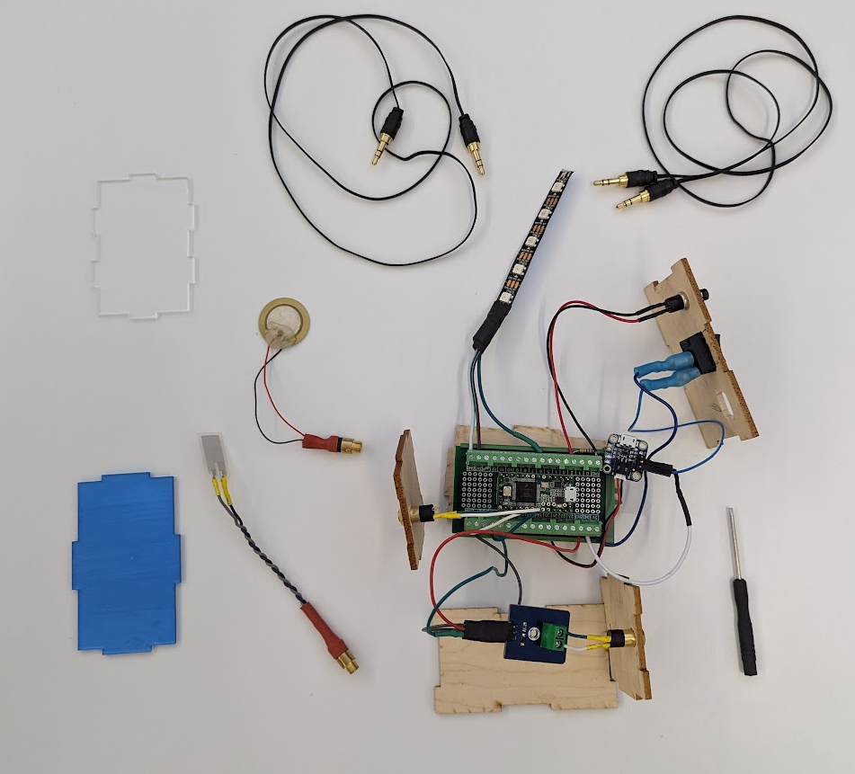 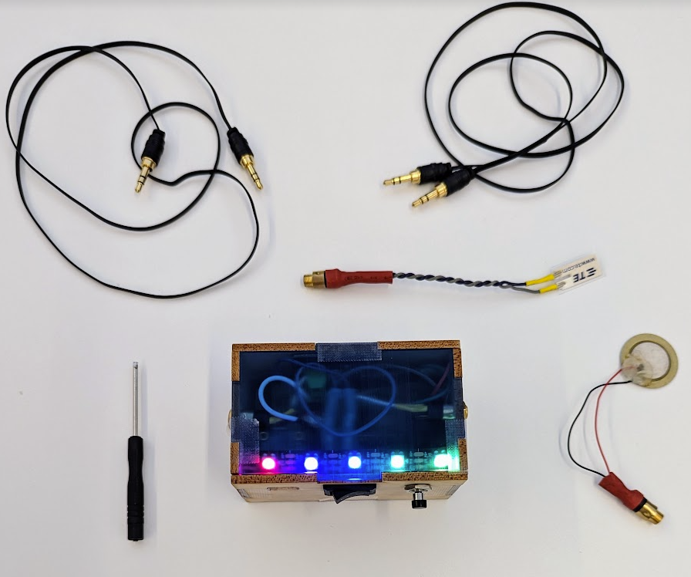

**Operation:**

Attach input end of the box to a 3.5mm wire and the piezo switch

Attach output end of the box to a 3.5mm wire and whatever you want to activate

The Wee Box utilizes an automatic thresholding procedure, place the piezo disc wherever you want to cause the activation (surface, object, forehead, throat, muscle, etc.)

If attached to person, have them acting normal during initialization procedures

Turn on Wee Box with Rocker Switch, it will cycle through a color wheel to indicate it is starting up

It will then countdown for 5 seconds by slowly un-lighting the LEDs

The LEDs will then count up for 5 seconds by slowly re-lighting the LEDs

During this count up, instruct the person to perform the action which is desired for switch activation

Following initialization procedures, the LEDs should turn green as activation is slowly increased.

If the threshold is crossed, the LED strip will light blue and activate the accesible switch

During operation if you would like to re-initialize just press and hold the pushbutton for about a second and the LEDs will start to countdown again

**Contact:**

Alexander Barry, MS, CCRC

Lead Engineer

[abarry@sralab.org](mailto:abarry@sralab.org)

312-238-1435

Rachel Kravitt, OTR/L

Lead Clinician

[rkravitt@sralab.org](mailto:rkravitt@sralab.org)

312-238-3947